**Pinniped Evolution**

In this exercise, you will trace the evolution of pinnipeds (the group including true seals, fur seals and sea lions, and walruses) to illustrate three important points regarding evolution:

1. Phylogenetic analyses may be used to distinguish between competing hypotheses regarding evolutionary history,

2. the independent evolution of a trait in different lineages (convergence) may be the most parsimonious explanation for observed patterns, and

3. the fossil record can be used as independent evidence to support a specific phylogeny in particular and the truth of evolution in general.

The groups you will examine include:

* Feliformia (the taxon including all catlike carnivores) – this will be your outgroup
* Ursidae (polar bears, grizzly bears, brown bears, etc.)
* Mustelidae (weasels, badgers, sea otters, etc)
* Phocidae (the “true” seals) – this family includes the subfamilies Phocinae and Monachinae
* Otariidae (the fur seals and sea lions)
* Odobenidae (walrus)

The taxa besides the Feliformia are all considered to be part of the Caniformia (or doglike carniovores). Both the feliforms and the caniforms are suborders within the mammal order Carnivora.

**PART 1.**

While virtually all evolutionary biologists believe that pinnipeds evolved from terrestrial ancestors, there has until recently been a debate as to whether or not the various groups evolved from a single ancestor. One specific competing hypothesis has been that the phocid seals evolved from a mustelid (e.g. a sea otter-like) ancestor, while the fur seals and walruses evolved independently from a bear-like ancestor.

**Question 1.** Draw aphylogeny thatrepresents the hypothesis outlined above. Include the feliforms as an outgroup.

**Question 2**. If this hypothesis is true, is the group Pinnipedia monophyletic or polyphyletic?

I have created a character matrix of some morphological characters for the groups listed above. You can access this in the “pinnipeds” file on Blackboard. Using Mesquite, you should:

* Create a tree for all the taxa
* Find the best possible tree
* Determine the length of the best tree
* Set Feliformia as the outgroup, and
* Trace the character history for the traits used in the analysis.

You can refer back to the instructions in the primates file if you forget how to do these.

**Question 3.** Is the single-origin or multiple-origin hypothesis best supported in explaining the evolution of the pinnipeds? Explain your answer.

Trace the evolution of the body size character.

**Question 4.** Proponents of the multiple-origin hypothesis have suggested that the large body size among monachine seals is a derived condition favored by adaptation to living in cold water (since larger animals lose heat less quickly than small animals). Given the information you have, does this idea seem likely? If not, how would explain the small body sizes seen in both mustelids and phocine seals?

Examine the molecular phylogeny for these groups shown below. (This is taken from Flynn, 1998, Mol. Phylo. Evol. 9: 414-426)

**Question 5.**

a.Does this independently-derived phylogeny agree that pinnipeds are a monophyletic group?

b. Who is the closest relative (mustelids or bears) to the pinnipeds in this phylogeny?

c. If this phylogeny is correct, for which groups is large body size a convergent trait?

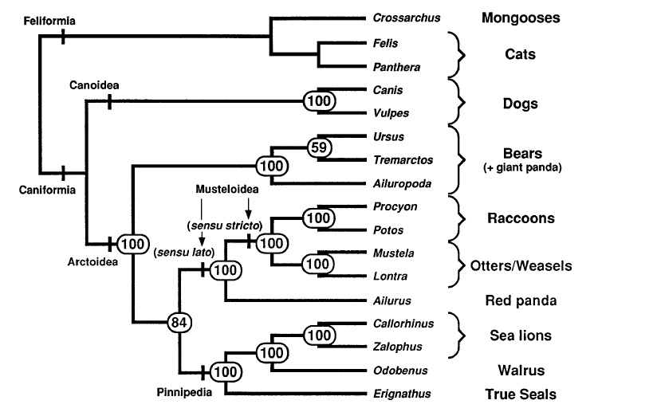

**PART 2.**

The data set in “pinnipeds+fossils” file contains all the (living) groups we just examined in addition to two new extinct groups found in the fossil record:

* *Enalioarctos* (which is dated to about 22-24 million years ago)
* *Pteronarctos* (dated to 15-19 million years ago)

It is thought from other evidence that the split between the feliforms and caniforms occurred around 42 million years ago, and that the two fossil groups above are transitions between a bear-like ancestral form and modern seals.

**Question 6.** Given the information above, draw a new predicted phylogeny that incorporates the two fossil groups into the morphological phylogeny from part 1.

**Question 7.** Test your prediction by running an analysis on the character matrix in the “pinnipeds+fossils” file. Does this phylogeny agree with your prediction? What does this match of phylogeny and relative fossil dating tell you?

**Question 8.**

a.Is *Enaliarctos* or *Pteronarctos* more closely related to modern seals (according to Mesquite)?

b. In what way was *Enaliarctos* more “seal-like” than bears? (You can use the trace character history function to answer this most easily)

c. In what way was *Enaliarctos* more “bear-like” than *Pteronarctos* or modern seals?

d. In what ways was *Pteronarctos* more “seal-like” than *Enalioarctos*?

e. Does this ordering of most “bear-like” to most “seal-like” agree with the dates of the groups in the fossil record? What does this tell you?